Jake Traut

4/25/16

CSCI 3656 PS 13

1. Trapezoidal method vs Forward Euler on Lorenz Equations

function ode = trapezoidal_lorenz(xyz, h, N)

%xyz holds the initial x y z values

%h is the time step size

%N is the number of time steps to take

x = []; y = []; z = []; t = [];

%fill in dynamic arrays with initial conditions

x(1) = xyz(1);

y(1) = xyz(2);

z(1) = xyz(3);

t(1) = 0;

for i = 2:N

t(i) = t(i-1) + h; %keep track of actual times

%and update associated position values for "time t"

xfe = x(i-1) + h*(16*(y(i-1) - x(i-1)));

yfe = y(i-1) + h*(45*x(i-1) - y(i-1) -x(i-1)*z(i-1));

zfe = z(i-1) + h*(x(i-1)*y(i-1) - 4*z(i-1));

x(i) = x(i-1) + h/2*(16*(y(i-1)-x(i-1)) + (16*(yfe - xfe)));

y(i) = y(i-1) + h/2*(45*x(i-1)-y(i-1)-x(i-1)*z(i-1) + (45*xfe - yfe - xfe*zfe));

z(i) = z(i-1) + h/2*(x(i-1)*y(i-1)-4*z(i-1) + (xfe*yfe - 4*zfe));

end

%plot(t,x)

%title('Trapezoidal Method on Lorenz equations time-domain');

plot3(x, y, z)

title('Trapezoidal Method on Lorenz equations State-Space');

ode = ('check the plot');

end

Time-domain plot for xyz = [1, 1, 1]

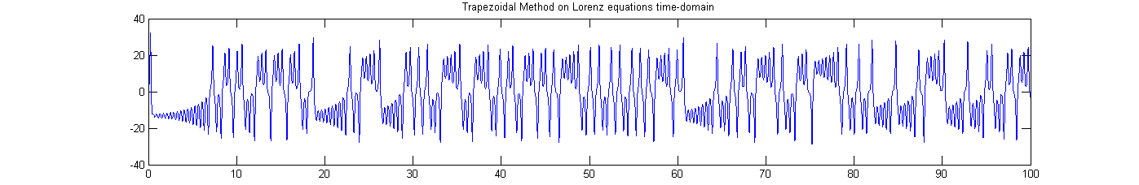

Time-domain plot for xyz = [1.01, 1.01, 1.01]

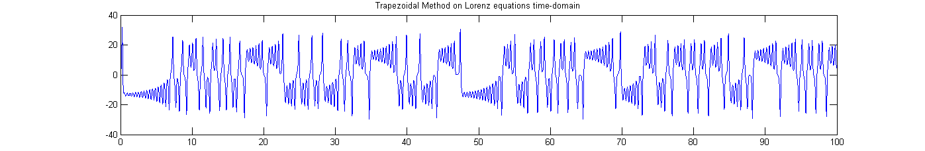

State-space plot for xyz = [1, 1, 1]

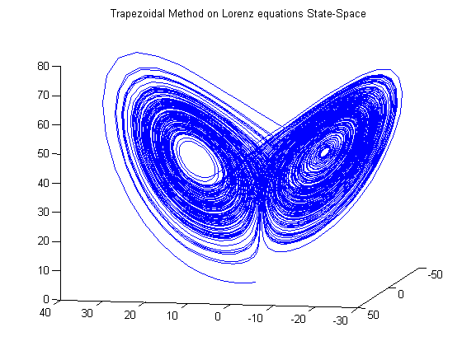

State-space plot for xyz = [1.01, 1.01, 1.01]

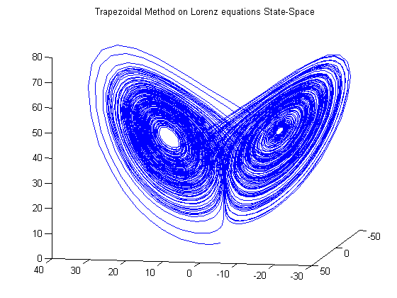

Forward Euler Time-domain plot for h = 0.0001 over 10 seconds (N = 100000)

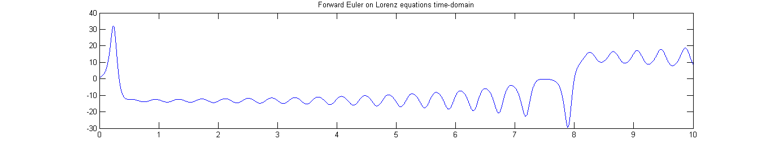

Trapezoidal Time-domain plot for h = 0.0001 over 10 seconds (N = 100000)

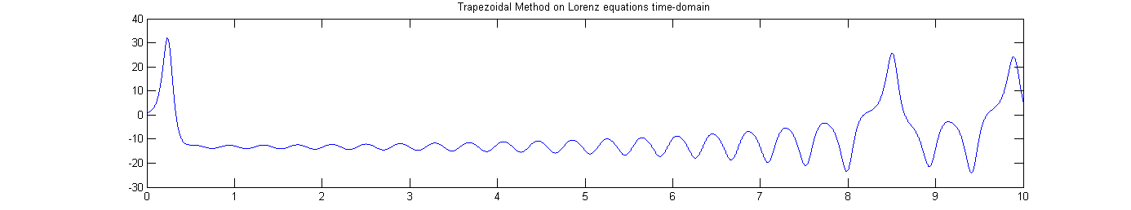

As you can see with this close up example, these two methods are fairly consistent until the 8th second when something more interesting happens, then FE shoots up and kind of remains at a plateau, while Trapezoidal continues oscillating at a greater magnitude. FE is only considering what’s ahead without any trial step, and takes a more drastic climb then levels out while Trapezoid includes a trial step (FE) and then back (BE) to handle this case better. As one would expect in considering more data per step, Trapezoidal method tends to be more accurate than the simple Forward Euler, with errors O(h^2) and O(h) respectively.